|  |  |  |  |  |
| --- | --- | --- | --- | --- |
| Decorative | | | | |
|  |  |  | |  |
| Market Segmentation  On electric vehicle market | | |
| Team Sanjay | |  |

|  |  |  |  |  |
| --- | --- | --- | --- | --- |
| Market Segmentation: Benefits, Types, and Use Cases | Coresignal | | | | |
|  |  |  | |
|  | Problem Statement  Conduct an in-depth analysis of the electric vehicle market in India utilizing the method of market segmentation, in order to identify specific segments within the market. Then, develop a comprehensive and practical plan for entering the market that specifically targets the segments that have been determined to be the most likely buyers of electric vehicles. | |

# Introduction

## 

The electric vehicle market is experiencing significant growth globally, with the increasing concern for environmental sustainability and government support for the adoption of electric vehicles. According to recent estimates, the global electric vehicle market size is expected to reach $567.3 billion by 2025, growing at a CAGR of 36.6% from 2020 to 2025. In India, the government has set a target of having 30% of vehicles on the road be electric by 2030, this creates a huge opportunity for the market to grow. With this increase in demand and growth, it is important to understand the market and its segments, to develop effective strategies for entering the market.

This report aims to conduct a market segmentation analysis of the electric vehicle market in India. The report will segment the market based on vehicle type, price range, and customer demographics, among other factors. By identifying specific segments within the market, this report will provide a clearer picture of the Indian electric vehicle market and help in developing a successful market entry strategy. The report will also cover the current market scenario, future market projections and key players in the market.

The report is structured as follows: First, we will provide an overview of the current state of the electric vehicle market in India. This will include market size, growth rate, and key players. Next, we will conduct a market segmentation analysis of the electric vehicle market in India, identifying specific segments within the market. Finally, we will provide recommendations for how to develop a successful market entry strategy based on the findings of the market segmentation analysis.

## Opportunities for growth

## 

1. Manufacturing and assembly of EVs: EV manufacturing and assembly opportunities in India with increasing demand
2. Sales and distribution of EVs: Growing market for EV sales and distribution with more EVs on the road, including dealerships and service centers
3. Charging infrastructure: Increasing demand for charging infrastructure with growing EV adoption

1. Battery recycling and management: Opportunities in EV battery recycling and management with increasing numbers of EVs on the road.
2. Fleet management: Opportunities for fleet management companies with growing use of EVs in fleets like ride-hailing and delivery.
3. Smart grid integration: Opportunities for grid integration and management companies with the growing use of EVs.

|  |  |
| --- | --- |
| Electric vehicle market segment in India | Download Scientific Diagram Data Source: We have analyzed about 7-8 datasets for various application regarding the segmentation of the EV market. From Which, I selected dataset for the differentiating the raw data about the electric vehicles for behavioral segmentation.  For Behavioral segmentation := ‘ElectricCarData_Norm.csv’ form Kaggle  <https://www.kaggle.com/datasets/geoffnel/evs-one-electric-vehicle-dataset?select=ElectricCarData_Norm.csv> |  |

Imported Libraries:

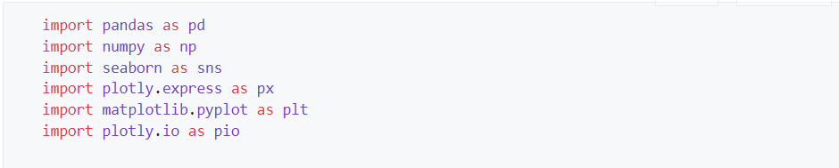

Data Preprocessing:

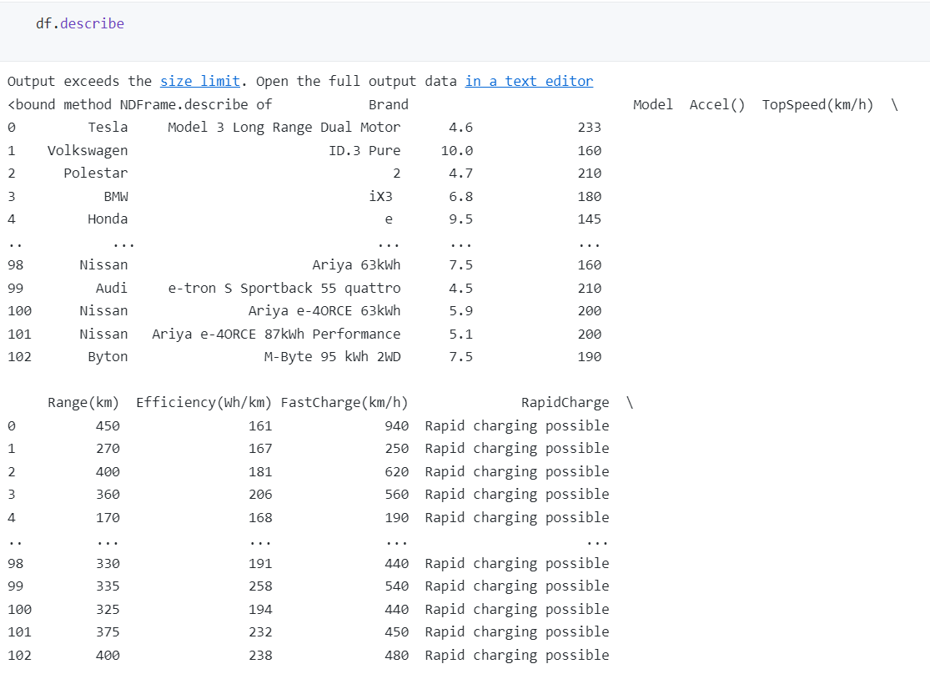

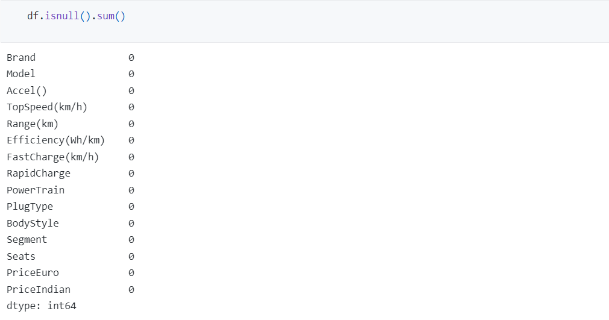

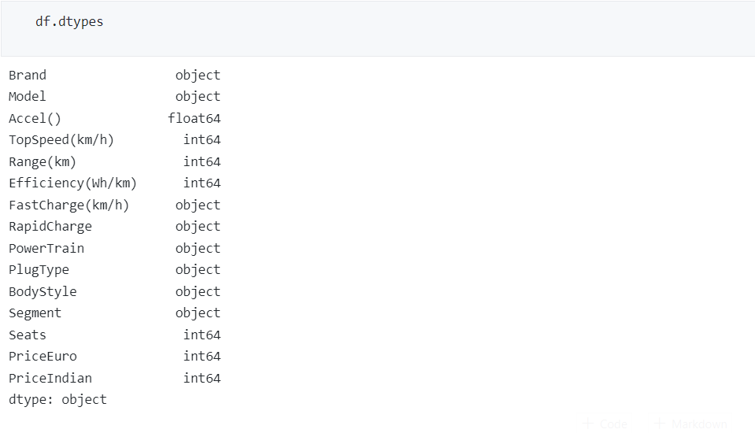

Market Segmentation:

## **Behavioral Segmentation:**

Behavioral segmentation is a method of dividing a market into groups based on consumer behavior, such as their attitudes, usage patterns, and loyalty towards a product or service. In the context of an electric vehicle market segmentation report, behavioral segmentation could include analyzing the following:

Attitudes towards electric vehicles: This could include understanding consumer perceptions and beliefs about the benefits and drawbacks of EVs, such as range anxiety and the availability of charging infrastructure.

Usage patterns: This could include understanding how frequently and under what conditions consumers use EVs, such as for daily commutes or long-distance travel.

Loyalty: This could include understanding how loyal consumers are to specific EV brands or models, as well as how likely they are to switch to a different brand or model.

Purchase behavior: this could include understanding the decision-making process, the factors that influence consumers to purchase an EV, and when they are likely to make the purchase.

By identifying specific segments of the market based on these behavioral factors, the report can provide insights into the key drivers of consumer behavior and help to inform a successful market entry strategy.

This Dataset consists of survey of data that is generated and collected from people, who have bought electric type of vehicle. It contains basic information about the purchase which is related to that of car, and its price.

For More information, we plotted Violin Plot. This is type of graph that generally gives the idea about the density and outliers by accordance of given attributes.

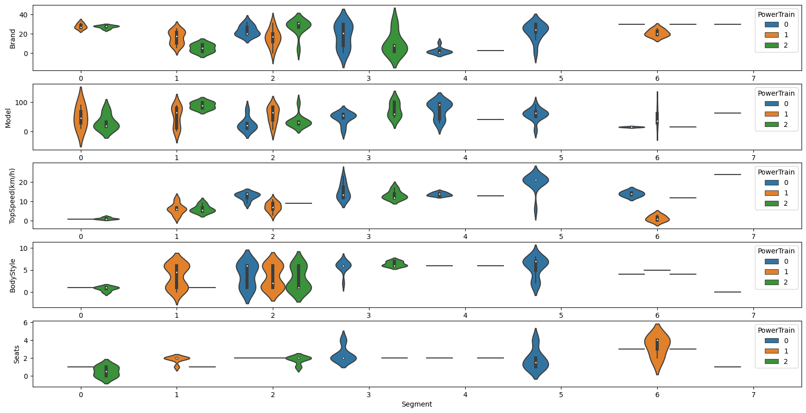

From this, we can conclude that,

1. The 2nd Segment is the most likely taken by the consumers, who bought various types of vehicles.
2. Whereas, the 7th segment is the most ignorable segment for the given dataset.
3. Consumers that lie in segment 6, are more likely to buy 4–6-seater vehicles, whereas, segment 0 customers bought 1–2-seater vehicles.
4. Relationship between the prices

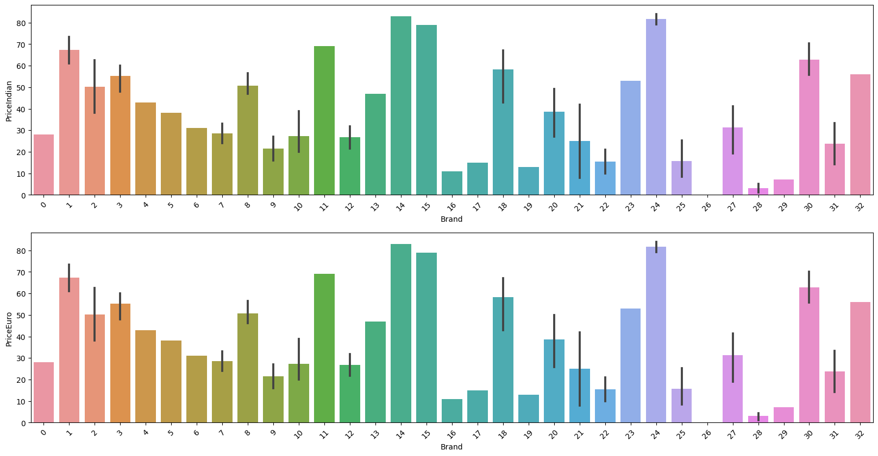

The price comparison for the Euro and Indian Rupee is almost Same.

1. Relationship between brand with its efficiency

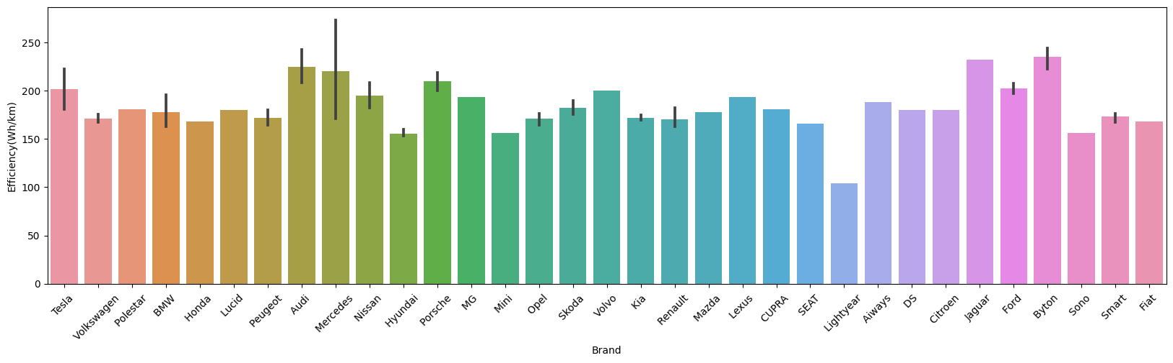

1. Count of the cars sold according its brand and model type

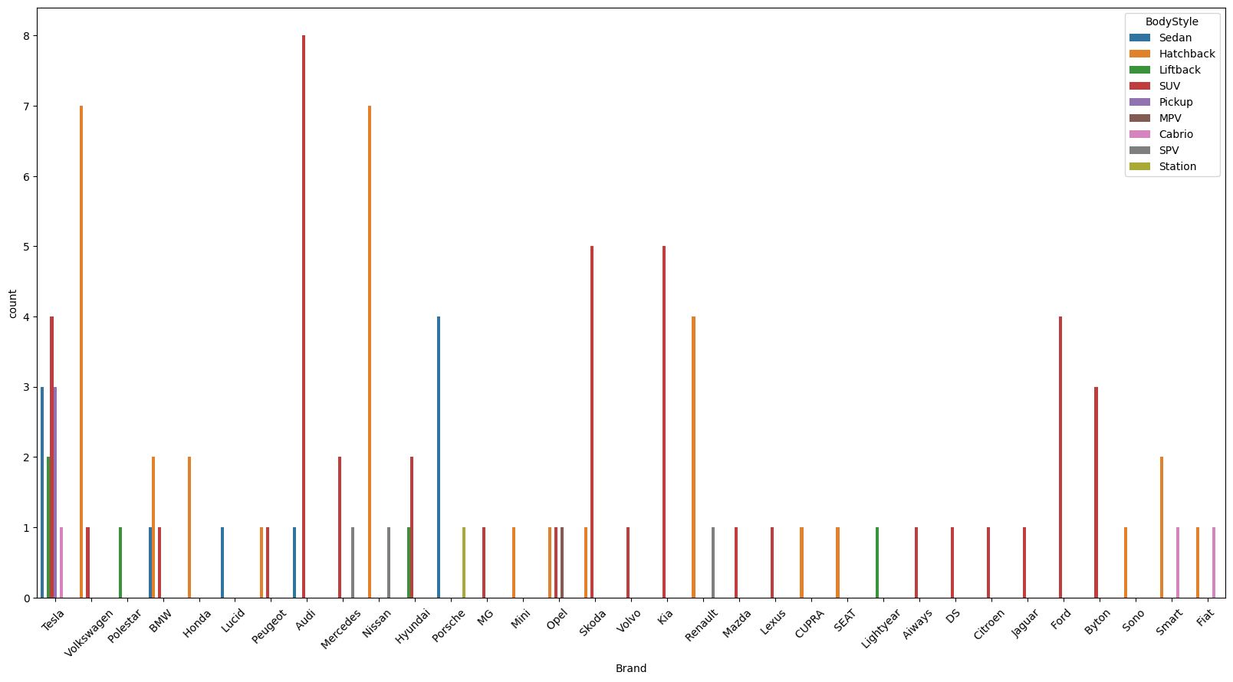

1. The count of the cars as per their charging types

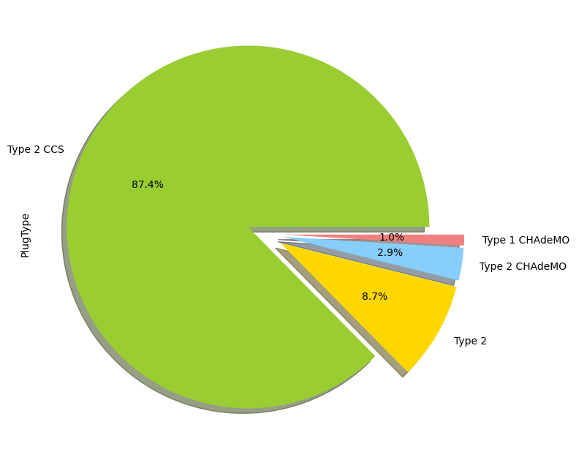

# Demographic Analysis:

In a electric vehicle market segmentation report, demographic analysis involves dividing the market into groups based on characteristics such as age, gender, income, education, and occupation. By identifying specific segments of the market based on these demographic factors, the report can provide insights into the preferences and purchasing power of different groups of consumers, which can help to inform a successful market entry strategy.

For example, the report could provide insight on which age groups are more likely to purchase electric vehicles, or which income groups are more inclined to afford higher-priced electric vehicles. Additionally, it could also show the difference in buying behavior across different regions, urban and rural areas, and other demographic characteristics.

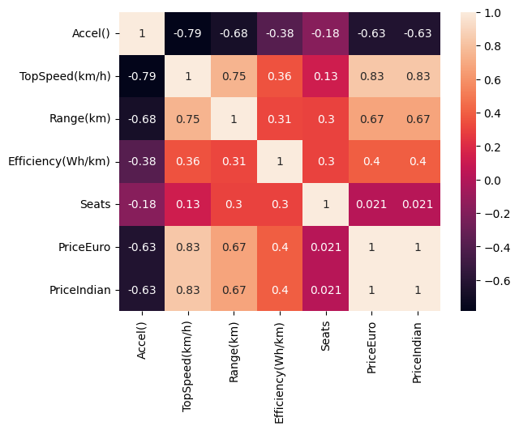

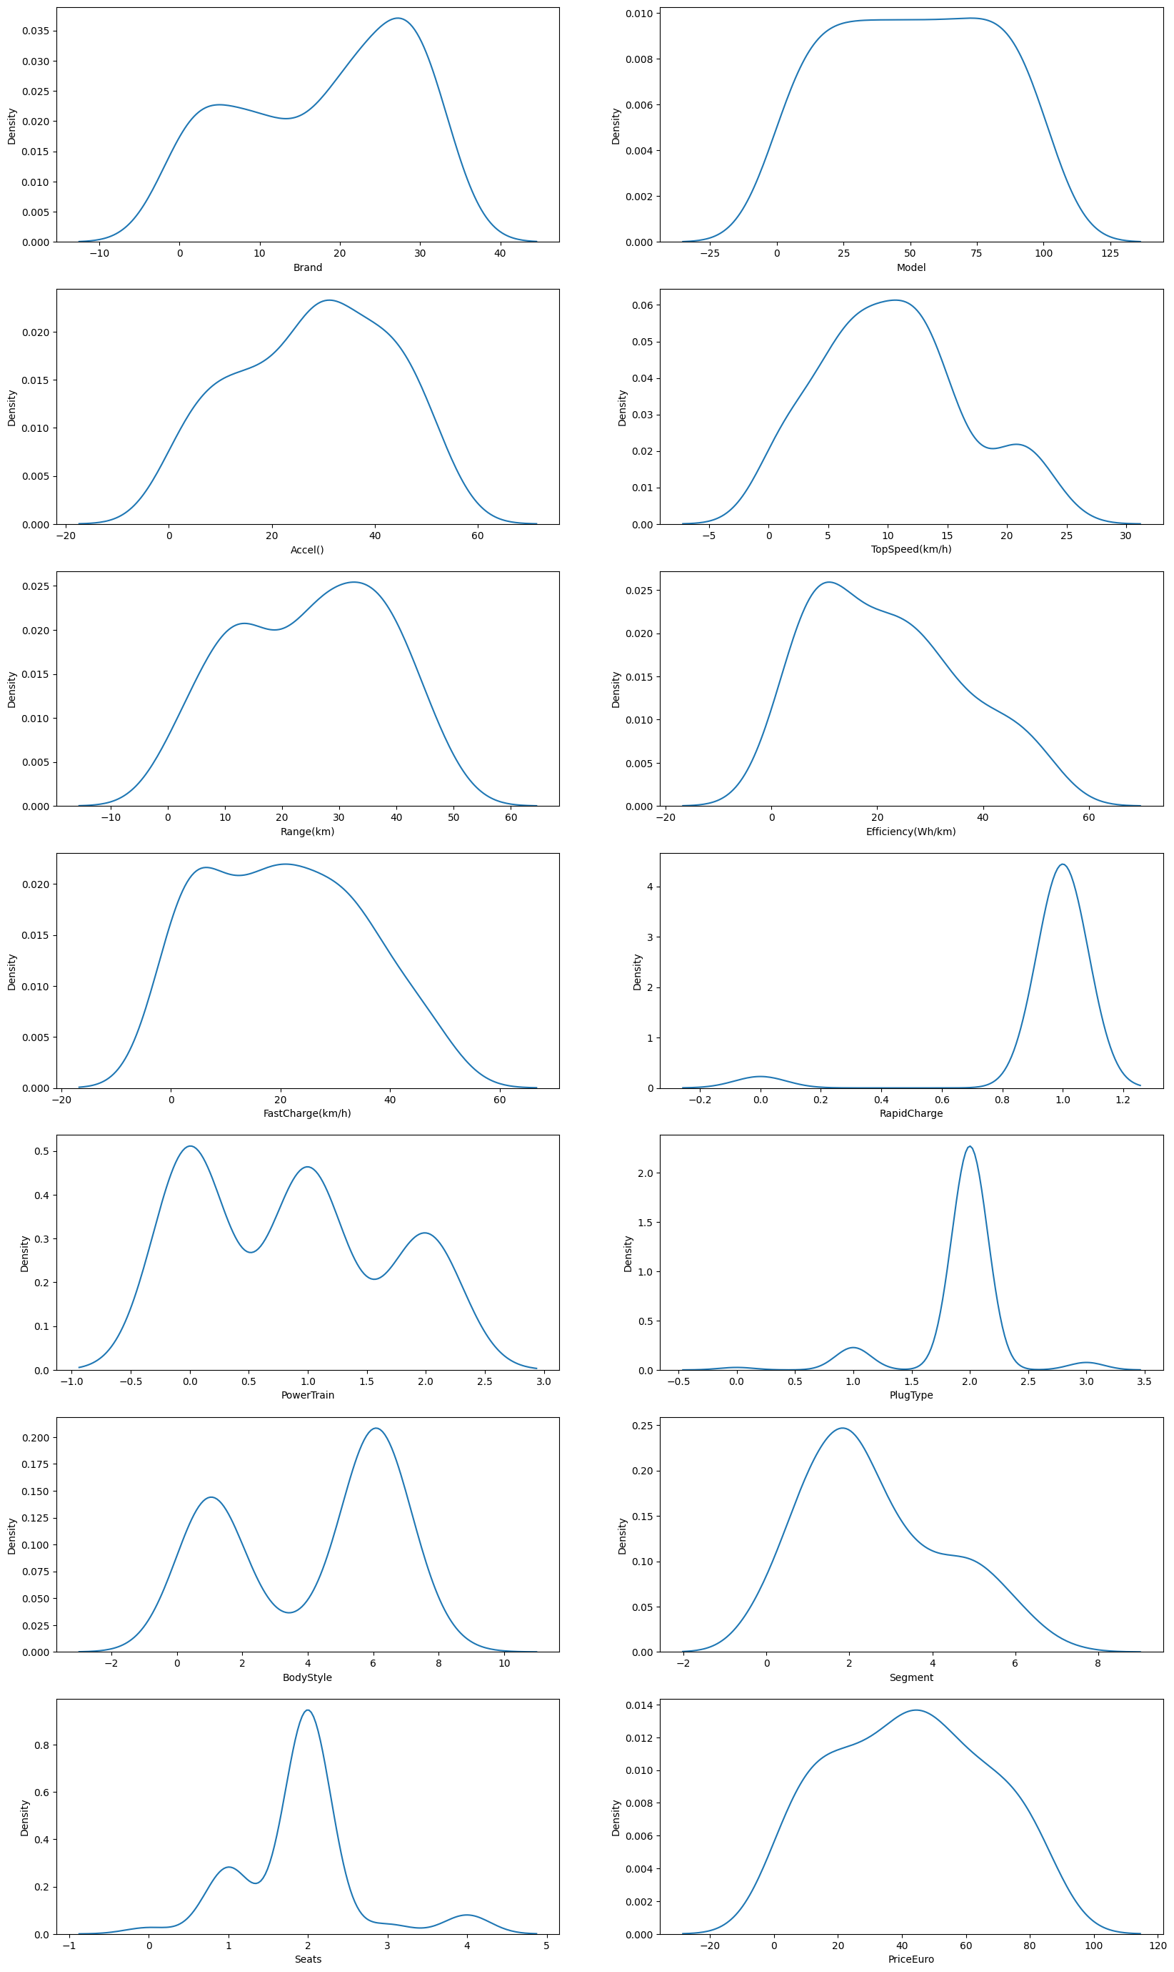

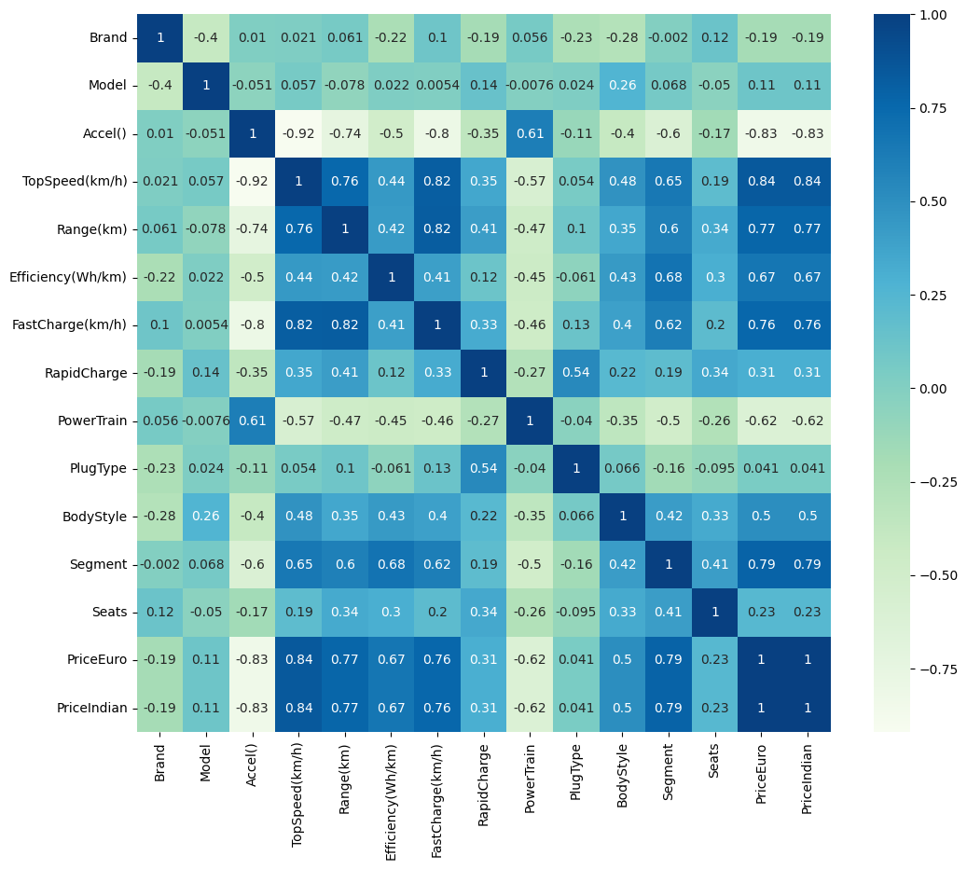

# Approaches used for Segmentation:

## Kmeans Clustering:

K-means is a popular unsupervised machine learning algorithm used for clustering. Clustering is the process of dividing a set of observations into subsets (called clusters) so that the observations in the same cluster are more similar to each other than to those in other clusters. The K-means algorithm is a centroid-based algorithm, or a distance-based algorithm, where we calculate the distances to assign a point to a cluster.

The algorithm aims to partition a set of n observations into k clusters, where each observation belongs to the cluster with the nearest mean. The number of clusters k is a user-defined parameter, and it is important to choose the appropriate number of clusters, as choosing a large k can lead to overfitting and choosing a small k can lead to underfitting.

The algorithm starts by randomly selecting k initial centroids, which are the points that represent the center of the clusters, and then iteratively assigns each observation to the cluster with the closest centroid. The assignment of observations to clusters is done based on the Euclidean distance between each observation and the centroids.

The centroid of each cluster is then recomputed as the mean of the observations in that cluster, and the process of assigning observations to clusters and updating centroids is repeated until convergence, where the assignment of observations to clusters does not change. The final result of the algorithm is k clusters, each represented by its centroid, and a set of n observations, each associated with one.

This below diagram will explain the working of the K-means Algorithm,

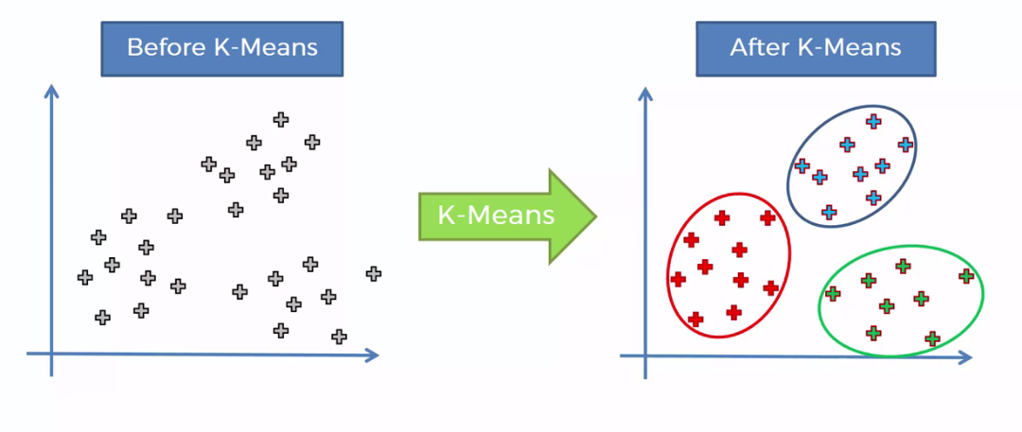

Choosing the number of ideal clusters using elbow method,

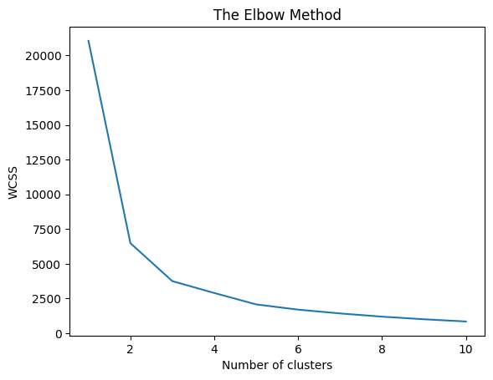

Data given by the elbow method, its is seen that the ideal number of cluster is either 3 or 5, as the elbow point is found as 3 and 5 so,

Take K=5, so, there will be 5 clusters in the segmentation, which is seen as after the segmentation as,

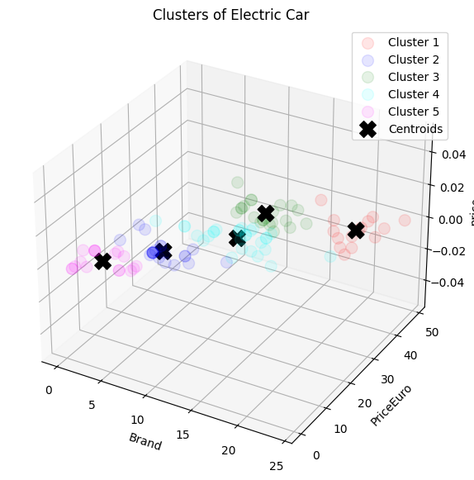

And, on addition, we have tried to plot the hierarchical cluster in form of dendrogram.

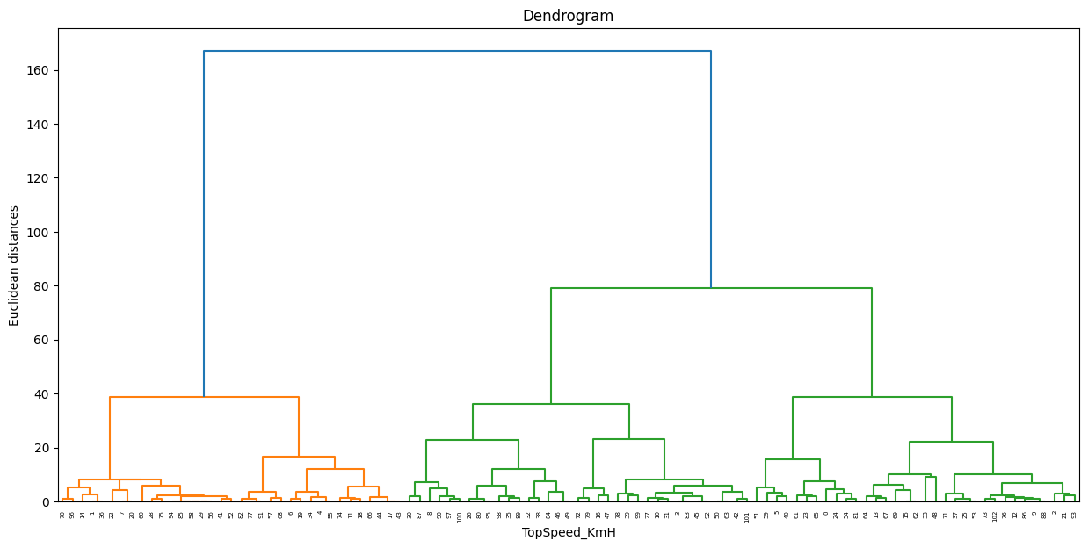

# Target Segments:

The report suggests that younger people, specifically those in the age range of 18-35, which are currently financially not stable are more open to buying electric vehicles as they are more aware of the environmental benefits and want to contribute to the cause. However, the report also reveals that this segment tends to have a lower disposable income and therefore, may not be able to afford the more expensive electric vehicle models. This highlights the need to target a group that is technology-savvy and environmentally conscious but has a higher disposable income, which is most likely to be in the age range of 35-50.

Additionally, the report also suggests that urban residents are more likely to buy electric vehicles as they have access to better infrastructure and are more informed about the technology. These urban residents are often more familiar with the benefits of electric vehicles and the charging infrastructure available in their area. The report suggests that targeting urban residents with a higher disposable income would be a promising market segment for electric vehicles.

It is also important to note that the report's findings and recommendations are based on the data and research available at the time of its creation and the market segments may vary depending on the current scenario, location and other factors.